[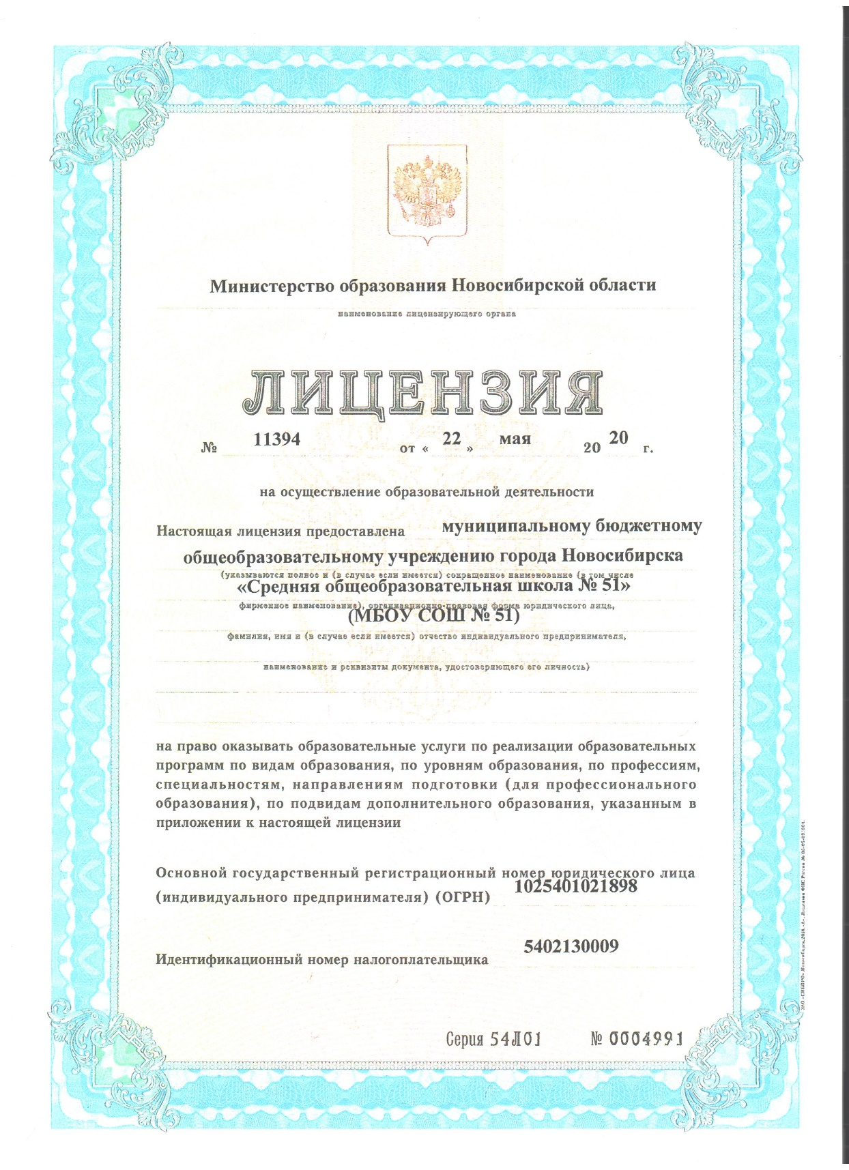](http://school-51.nios.ru/wp-content/uploads/2020/05/01.jpg)

[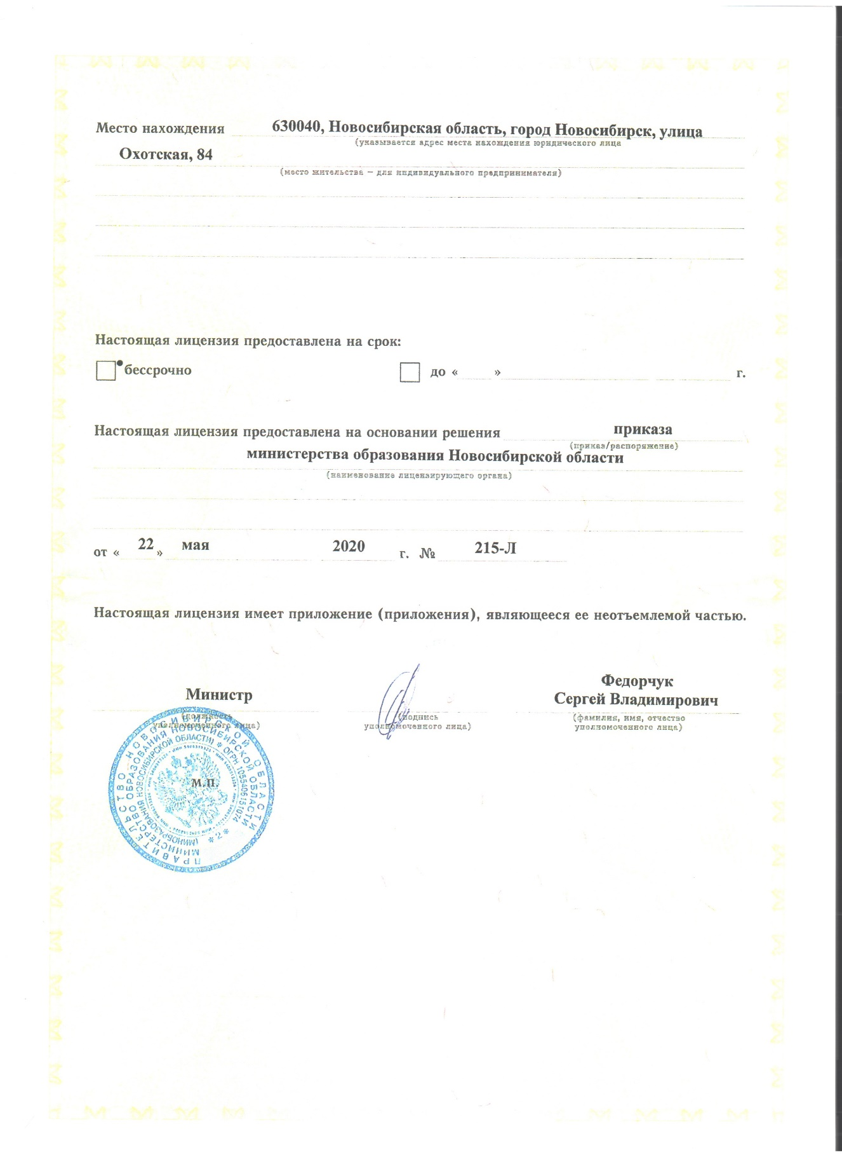](http://school-51.nios.ru/wp-content/uploads/2020/05/02.jpg)[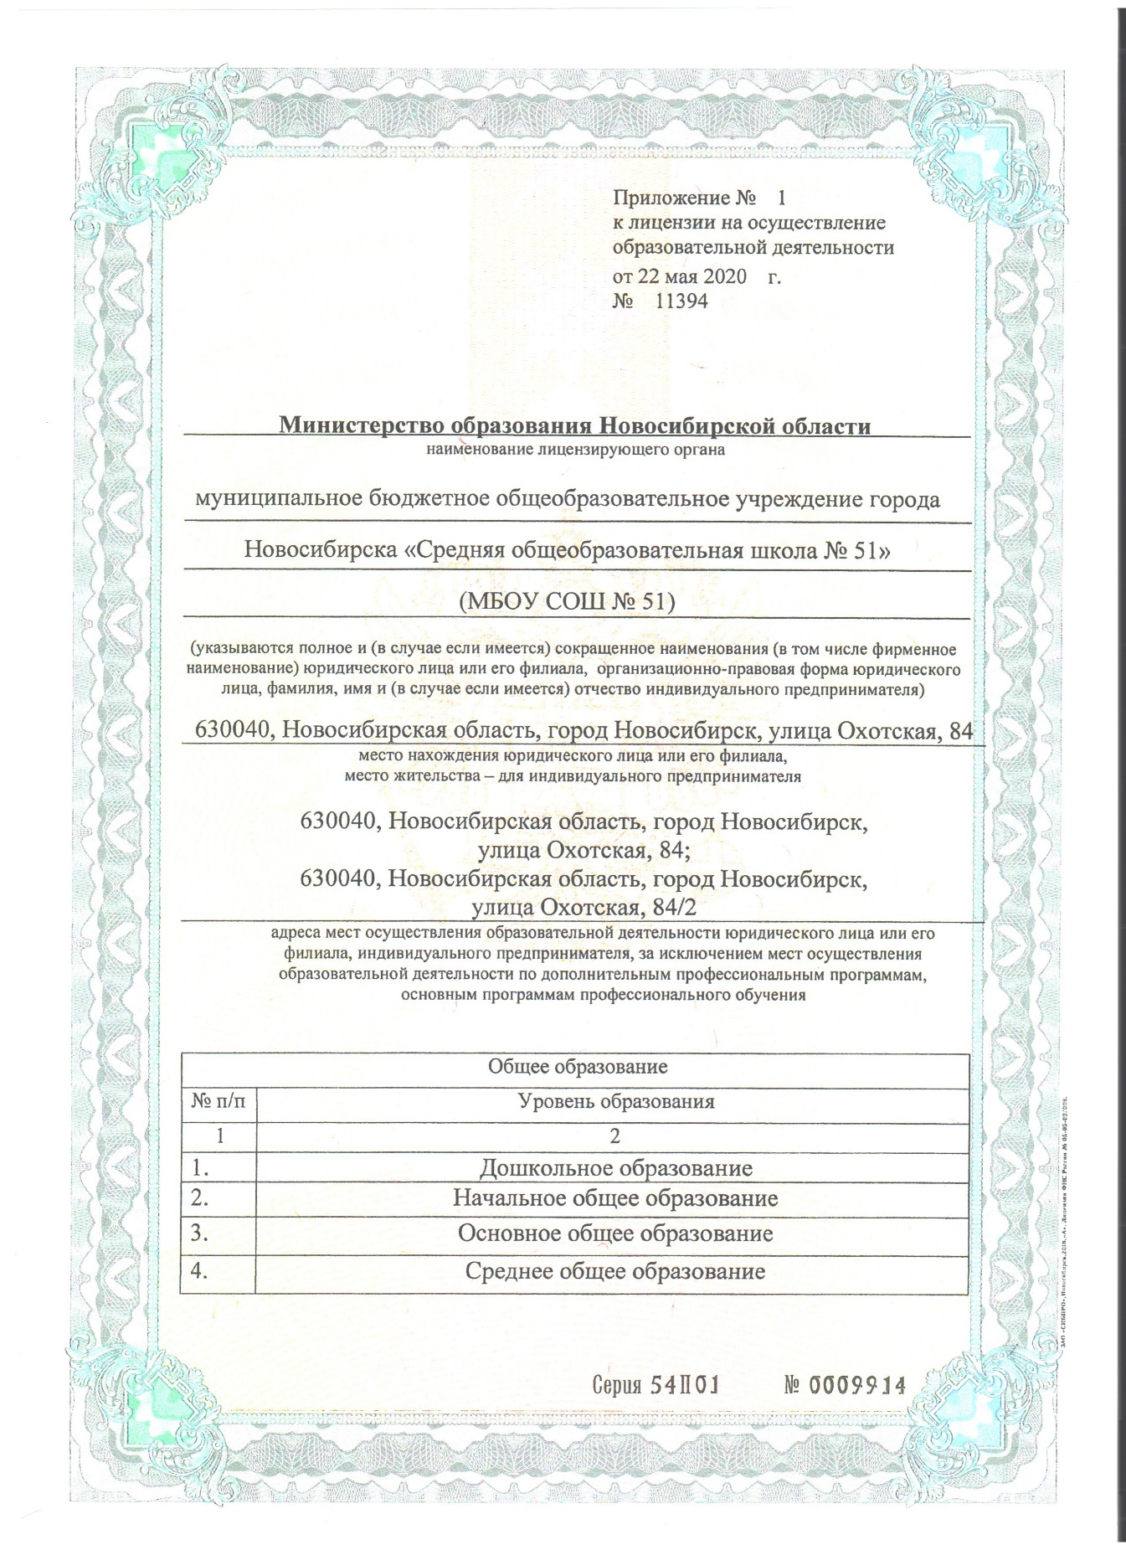](http://school-51.nios.ru/wp-content/uploads/2020/05/03.jpg)

[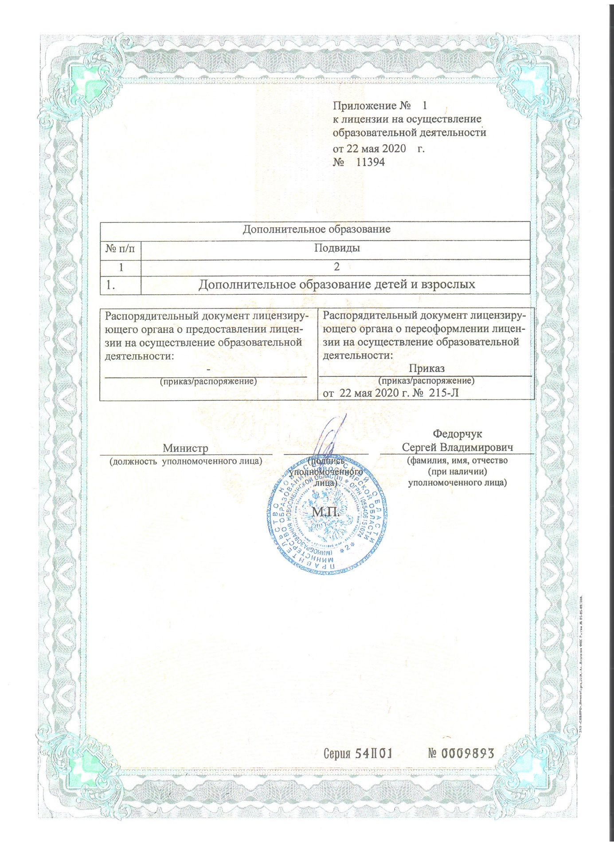](http://school-51.nios.ru/wp-content/uploads/2020/05/04.jpg)